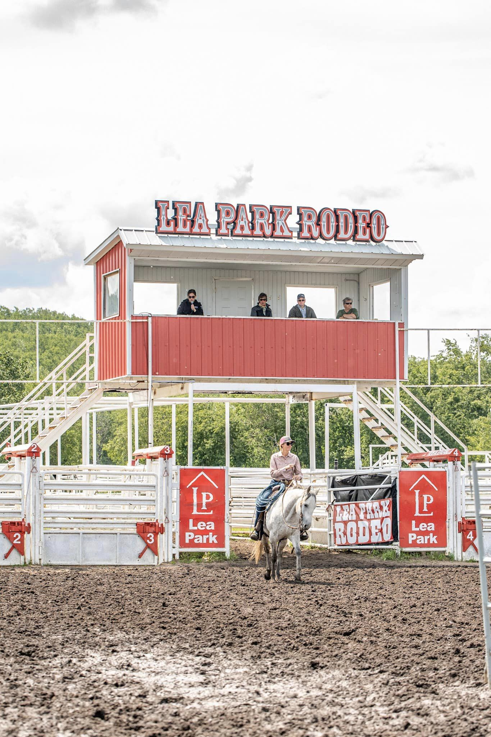  Photo Credit Circle E Photography-Jessie Selte  Lea Park Rodeo Grounds  Located 17km north of Marwayne along highway 897. The Lea Park Rodeo grounds is the perfect location to host this event. We are excited at the opportunity to use this facility again  - Located in Jubilee Park this venue is the perfect location to host this event again. The 2022 CCDA Finals that we hosted here was an overwhelming success and we received great feedback from competitors and spectators. |  |  | Lloydminster Stock Dog Club  About Us  The Lloydminster Stock Dog Club is a group of local ranchers, farmers and stock dog enthusiasts, who use working dogs for trialing and ranch work. We promote the proper use of stock dogs and host many events throughout the year. Our members have years of experience and know first-hand the importance of working dogs.  The club members are Justin Hozak, Sherry Creech, Sheila Phillips, Rosemary Currie, Alanna Leach, Clare Lawrence, Glen Grant, Rebecca Young, and Darren and Casey Hannis  We are excited to host the CCDA Finals and look forward to creating another high caliber event for our competitors and spectators.  Contact Us  Email: lloydminsterstockdogclub@gmail.com  Facebook: Lloydminster Stock Dog Club  Casey Hannis: (306)821-1265  Justin Hozak: (587) 217-9104  Rosemary Currie (306) 893-8103  Sherry Creech (780) 871-8866 |  |  | Canadian Cattle Dog Association Finals 2024  - July 5-7, 2024  - Lea Park, Alberta  Hosted by the Lloydminster Stock Dog Club

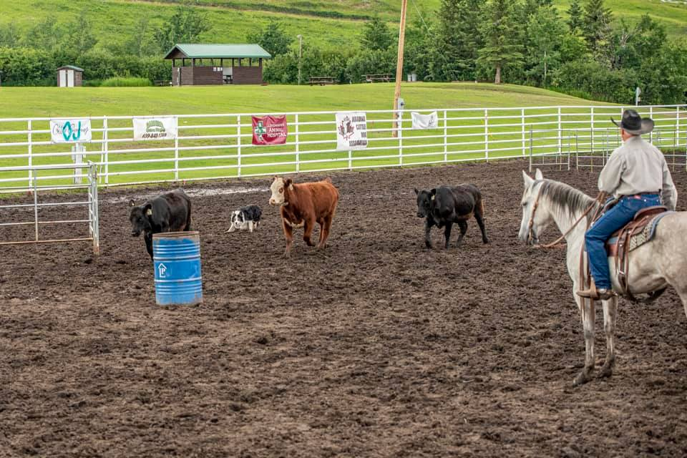  Why Sponsor the CCDA Finals?  The CCDA Finals is the largest cattle dog event in Canada with close to 100 participants and spectators coming to support this trial.  In past years the CCDA Finals have paid out thousands of dollars in prize money every year, enticing the best handlers and dogs to come and compete.  Putting on an event of this magnitude is expensive, and we cannot do it without the generosity from the community.  This event gives sponsors great exposure for our local community but also Canadian wide recognition. |  |  | Sponsorship Opportunities  Gold Sponsor-$500  - Includes a sponsored obstacle that will be announced on the event livestream  - Company name and logo printed in the event program  Silver Sponsor-$350  - Includes hanging company banner along the arena that will be announced in between runs.  - Company name/logo printed in the event program  Bronze Sponsor-$200  - Includes company or individual name printed in the event program  We are extremely thankful to every sponsor that helps us with this event. We truly could not put on this fantastic event without you.  Please contact the Lloydminster Stock Dog Club to inquire about sponsorship opportunities. |  |  | 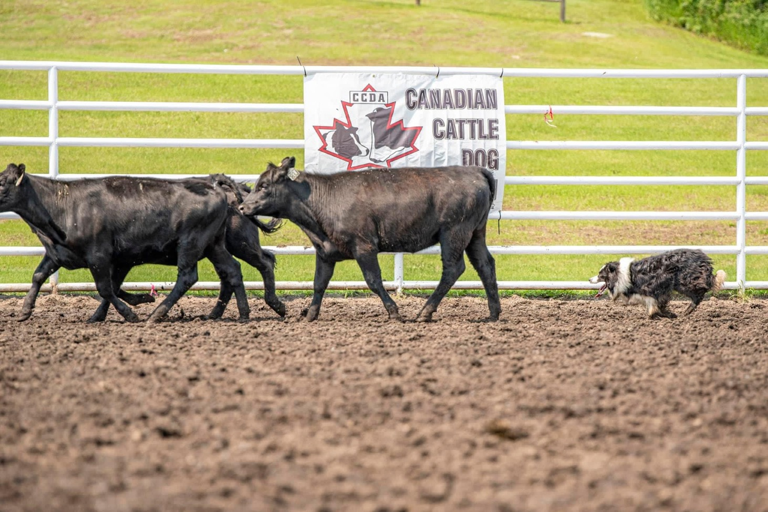  Cattle Dog Trialing  Cattle dog trialing consist of a handler and a working bred dog, moving a set of cattle through an obstacle course. There are different levels of classes based on the handler’s experience (Open, Intermediate, Novice and Junior), age of the dog (Nursey is for dogs 3 and under) and the horseback class, where the handler is mounted on a horse and helps the dog move the cattle through the course.  Trialing has evolved from using dogs for everyday ranch work. Many handlers own a variety of stock and use dogs to help on their operations. The ranch roots of this sport have created a unique but practical event for handlers to showcase what they can do with their dogs.  Stock dog and cattle dog trialing is a fast growing sport, that is gaining new followers and participants every year.

